1. **Pull the Busy-box image to your local system, tag it, and push it to the Docker Hub repository "yourname_cloudethix_busybox.**

root@DESKTOP-PDOJQQA:~# **docker pull busybox:latest**

latest: Pulling from library/busybox

Digest: sha256:ba76950ac9eaa407512c9d859cea48114eeff8a6f12ebaa5d32ce79d4a017dd8

Status: Image is up to date for busybox:latest

docker.io/library/busybox:latest

root@DESKTOP-PDOJQQA:~# **docker image ls -a**

REPOSITORY TAG IMAGE ID CREATED SIZE

image latest 338075de0bc0 6 days ago 584MB

vivekmore5292/local_app_images latest 338075de0bc0 6 days ago 584MB

vivekmore5292_cloudethix_busybox latest 9211bbaa0dbd 4 weeks ago 4.26MB

ubuntu latest 174c8c134b2a 5 weeks ago 77.9MB

root@DESKTOP-PDOJQQA:~# **docker image tag busybox:latest vivekmore5292/vivek_cloudethix_busybox:latest**

root@DESKTOP-PDOJQQA:~# **docker image push vivekmore5292/vivek_cloudethix_busybox:latest**

The push refers to repository [docker.io/vivekmore5292/vivek_cloudethix_busybox]

82ae998286b2: Mounted from library/busybox

latest: digest: sha256:7de5fa822a9d1e507c36565ee0cf50c08faa64505461c844a3ce3944d23efa35 size: 527

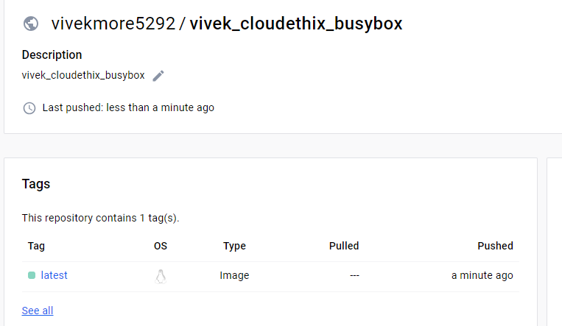

1. In your project directory, create a Dockerfile (named Dockerfile) with the following content.  
       FROM nginx:latest  
       COPY custom-index.html /usr/share/nginx/html/index.html  
     Ensure you also have a file named custom-index.html in the same directory.  
     Build the Docker image using the Dockerfile you created and push it your repository.   
     Delete the local image.  
     Start a new container using the custom Nginx image that you just pushed.  
     Map port 8080 on your host to port 80 in the container. Check the container page in browser.

root@DESKTOP-PDOJQQA:~# **docker image build -t vivekmore5292/vivek_cloudethix_busybox:latestv1 .**

[+] Building 0.3s (7/7) FINISHED docker:default

=> [internal] load .dockerignore 0.0s

=> => transferring context: 2B 0.0s

=> [internal] load build definition from Dockerfile 0.0s

=> => transferring dockerfile: 221B 0.0s

=> [internal] load metadata for docker.io/library/nginx:latest 0.0s

=> [internal] load build context 0.0s

=> => transferring context: 115B 0.0s

=> CACHED [1/2] FROM docker.io/library/nginx:latest 0.0s

=> [2/2] COPY custom-index.html /usr/share/nginx/html/index.html 0.1s

=> exporting to image 0.1s

=> => exporting layers 0.1s

=> => writing image sha256:663a6796820e824f74a84fcb44893e8cc8ff8701e3cd71ea5745976426a155b1 0.0s

=> => naming to docker.io/vivekmore5292/vivek_cloudethix_busybox:latestv1 0.0s

root@DESKTOP-PDOJQQA:~# **docker images**

REPOSITORY TAG IMAGE ID CREATED SIZE

vivekmore5292/vivek_cloudethix_busybox latestv1 663a6796820e 31 seconds ago 187MB

image latest 338075de0bc0 7 days ago 584MB

root@DESKTOP-PDOJQQA:~# **docker push vivekmore5292/vivek_cloudethix_busybox:latestv1**

The push refers to repository [docker.io/vivekmore5292/vivek_cloudethix_busybox]

10689bab9684: Pushed

b074db3b55e1: Mounted from library/nginx

e50c68532c4a: Mounted from library/nginx

f6ba584ca3ec: Mounted from library/nginx

01aaa195cdad: Mounted from library/nginx

2a13e6a7cca6: Mounted from library/nginx

370869eba6e9: Mounted from library/nginx

7292cf786aa8: Mounted from library/nginx

latestv1: digest: sha256:c16396c6b188fbac94775dd28b51fe7dbc454df2c246cd629f70171330790177 size: 1985

root@DESKTOP-PDOJQQA:~# **docker images**

REPOSITORY TAG IMAGE ID CREATED SIZE

vivekmore5292/vivek_cloudethix_busybox latestv1 663a6796820e 4 minutes ago 187MB

vivekmore5292/local_app_images latest 338075de0bc0 7 days ago 584MB

root@DESKTOP-PDOJQQA:~# **docker image rm vivekmore5292/vivek_cloudethix_busybox:latestv1**

Untagged: vivekmore5292/vivek_cloudethix_busybox:latestv1

Untagged: vivekmore5292/vivek_cloudethix_busybox@sha256:c16396c6b188fbac94775dd28b51fe7dbc454df2c246cd629f70171330790177

Deleted: sha256:663a6796820e824f74a84fcb44893e8cc8ff8701e3cd71ea5745976426a155b1

root@DESKTOP-PDOJQQA:~# **docker container run -itd -p 8081:80 --name vivek1 vivekmore5292/vivek_cloudethix_busybox**

Unable to find image 'vivekmore5292/vivek_cloudethix_busybox:latest' locally

latest: Pulling from vivekmore5292/vivek_cloudethix_busybox

Digest: sha256:7de5fa822a9d1e507c36565ee0cf50c08faa64505461c844a3ce3944d23efa35

Status: Downloaded newer image for vivekmore5292/vivek_cloudethix_busybox:latest

468287fbf3d4df628c12715344a0d03caaf0296754a75b7a41998101acca716b

root@DESKTOP-PDOJQQA:~# **netstat -tunlp**

Active Internet connections (only servers)

Proto Recv-Q Send-Q Local Address Foreign Address State PID/Program name

tcp 0 0 0.0.0.0:8081 0.0.0.0:* LISTEN 158334/docker-proxy

tcp 0 0 127.0.0.53:53 0.0.0.0:* LISTEN 152/systemd-resolve

tcp 0 0 0.0.0.0:22 0.0.0.0:* LISTEN 273/sshd: /usr/sbin

root@DESKTOP-PDOJQQA:~# **curl localhost:8081**